Class Reg Number

Candidate Name _____________________________

MERIDIAN JUNIOR COLLEGE

__________________________________________________________________________
H2 Chemistry 9647/2
Paper 2 Structured 20 September
2 hours
Additional Materials: Data Booklet
__________________________________________________________________________

INSTRUCTIONS TO CANDIDATES
Write your name, class and register number in the spaces provided at the top of this page.
Answer all questions in the spaces provided on the question paper.
All working must be shown clearly.

FOR EXAMINER’S USE
Q1 | / 12
Q2 | / 15
Q3 | / 12
Q4 | / 14
Q5 | / 8
Q6 | / 11
Total | / 72

INFORMATION FOR CANDIDATES
The number of marks is given in brackets [ ] at the end of each question or part question.
You are reminded of the need for good English and clear presentation in your answers.

This document consists of 22 printed pages.
Answer all the questions in the space provided.
1 Planning (P)

Some iron tablets, containing iron (II) sulfate, were left on the shelf for too long such that some of the iron (II) sulfate was oxidised into iron (III) sulfate.

You are to carry out a titrimetric analysis to determine the percentage by mass of Fe³⁺ ions present in the sample of oxidised iron tablets.

The following reagents are provided to enable the experiment to be carried out:
- Sample of oxidised iron tablets
- 1.00 mol dm⁻³ sulfuric acid, H₂SO₄
- 0.0110 mol dm⁻³ potassium dichromate (VI), K₂Cr₂O₇
- N-phenylanthranilic acid as indicator
(1 cm³ of indicator produces a violet colour change at end-point)
- Zinc powder

(a) The oxidised iron tablets must first be dissolved in water to liberate the Fe²⁺ and Fe³⁺ ions. A suitable quantity of sulfuric acid is then added to the solution.
Suggest a reason why sulfuric acid is used in the preparation of the mixture of Fe²⁺ and Fe³⁺ solution.

[1]

(b) Write the ionic equation for the reaction between Fe²⁺ ions and potassium dichromate (VI) solution.

[1]
(c) An unoxidised sample of iron tablet was dissolved and made up to 250 cm³. 25.0 cm³ of the Fe²⁺ ions solution required 15.00 cm³ of potassium dichromate (VI) to reach an end-point in a titration.
Calculate the mass of FeSO₄ in the unoxidised sample of iron tablet that was used.

[2]

(d) A sample of oxidised iron tablet is equally divided and dissolved to give two portions of 250 cm³ acidified Fe²⁺ and Fe³⁺ ions solutions for analysis.
Procedure 1
To one portion, the Fe³⁺ (aq) should be converted into Fe²⁺ (aq) first using excess zinc metal, before titration against potassium dichromate (VI) solution.
Procedure 2
To the other portion, the Fe²⁺ (aq) can be directly titrated against potassium dichromate (VI) solution.
List, in the order in which they will be made, the steps of how Procedure 1 can be carried out. Your plan should include any quantity or measurements required, as well as how the end of any reaction which occurs may be determined. You have the use of common apparatus that is available in a college laboratory.

[5]
(e) Using the following information, calculate the percentage by mass of Fe³⁺ ions in the oxidised iron tablet sample.

No. of mol of Fe²⁺ (in 250 cm³) from Procedure 1 = p
No. of mol of Fe²⁺ (in 250 cm³) from Procedure 2 = q
A_{r}: O, 16.0; S, 32.1; Fe, 55.8

[2]

(f) By modifying Procedure 1, suggest another means by which the amount of Fe³⁺ in an oxidised iron tablet sample can be determined.

[1]

[Total: 12]
2(a) The melting points of the chlorides of the Period 3 elements magnesium to phosphorous, are given below.
Compound | Magnesium chloride | Aluminium chloride | Phosphorous pentachloride
Melting point / ºC | 714 | 178 | 162

- Account for the difference in the melting points of magnesium chloride and aluminium chloride, in terms of structure and bonding.

- Explain the difference in the pH values when AlCl₃ and PCl₅ are separately dissolved in water. Write equations to support your answer.

[6]
(b) Elements K, L, M and N are four consecutive Period 3 elements. The table below shows the first four ionisation energies of elements K, L, M and N.
Element | First I.E | Second I.E | Third I.E | Fourth I.E
K | 577 | 1820 | 2740 | 11600
L | 786 | 1580 | 3230 | 4360
M | 1060 | 1900 | 2920 | 4960
N | 1000 | 2260 | 3390 | 4540

  - For element K, briefly explain why the energy difference between the removal of the 2nd and 3rd electrons is smaller than that between the removal of the 3rd and 4th electrons.

(ii) Explain why the first ionisation energy of element N is lower than that of element M.

(iii) Element T is a Period 2 element in the same group as element M. Suggest with reasoning why element M can form an oxo-anion of formula MO₄³⁻ but element T cannot.

[4]
(c) Nitrosyl chloride, NOCl, dissociates according to the following equation.
2 NOCl(g) 2 NO(g) + Cl₂(g)
The equilibrium constant, K_{p}, is 0.05 atm at 200 ºC. At 400 ºC, the percentage dissociation of NOCl is found to be 40 % and the total pressure at equilibrium is 2 atm.
(i) Calculate the value of K_{p} at 400 ºC.
(ii) Comparing the K_{p} values at the two temperatures, state and explain whether the forward reaction is endothermic or exothermic.

(iii) Considering the equilibrium at 400 ºC, explain why the apparent molar mass of the equilibrium mixture decreases when the total pressure of the system is halved.

[5]

[Total: 15]
3 The elements of Group VII were discovered in the 17th century by different European scientists. Due to their high reactivity, they are found in the environment only in compounds such as halides in minerals and halogenated organic compounds in living organisms.
- The plots of PV/RT against P for one mole of an ideal gas and one mole of HCl at 100 K are given below.

- Show clearly, on the same axes, how one mole of HF will behave at the same temperature of 100 K.

HCl (100 K)
PV/RT

1.0
Ideal Gas

P

- Explain the difference in behaviour between HF and HCl at 100 K.

(iii) Explain what happens when the HCl gas is heated to 400 K.
Illustrate your answer clearly on the same axes in a(i).

[4]
- 2-chloropropane can be made by the chlorination of propane.

- Outline the reaction mechanism of its formation, labelling each step in the mechanism appropriately.

(ii) Explain why the reaction requires only a flash of ultraviolet light rather than prolonged radiation.

[3]
- Bromine and fluorine can react to form an interhalogen liquid compound BrF₃, a common fluorinating agent. This compound can react with silicon (IV) oxide according to the following equation.

4BrF₃ + 3SiO₂ → 3SiF₄ + 2Br₂ + 3O₂
The amount of bromine produced can be determined by reacting it with sodium thiosulfate solution, Na₂S₂O₃ (aq).
- Write the equation for the reaction between bromine and thiosulfate ions in acidic medium.

(ii) Determine the mass of SiF₄ produced, to one decimal place, if 30.0 cm³ of 0.100 mol dm⁻³ Na₂S₂O₃ solution was required to completely react with the bromine liberated from the reaction between BrF₃ and SiO₂.

- The bromine produced could also be reacted with cold aqueous sodium hydroxide to form a mixture of products.

State the type of reaction that it has undergone and write a balanced equation for the reaction involved.

[5]
[Total: 12]
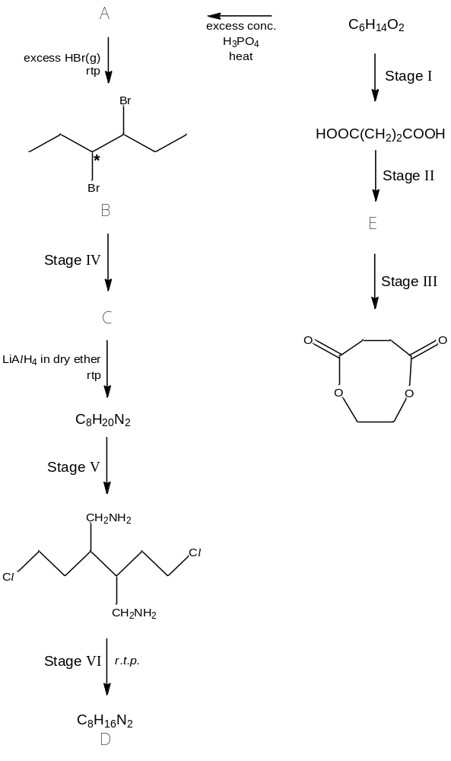
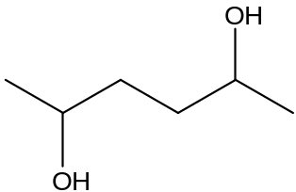
4 The reaction scheme below shows the syntheses of carboxylic acid derivatives and nitrogen compounds.
A
C
DV
E
B

(a) (i) Compound A exists as a mixture of stereoisomers.
(1) Name the type of isomerism.

(2) Determine the number of isomers present.

- Draw the structures for C, D and E in the boxes provided below.
C | D
E

(iii) State the reagents and conditions for Stage I – V in the spaces provided.
 | Reagents | Conditions
Stage I | 1.  2. | 1.  2.
Stage II
Stage III
Stage IV
Stage V
[11]
- Compound B is found to be optically inactive. Suggest a reason for this observation.

[1]
(c) Identify the type of hybridisation of the carbon atom (marked with an *) in B, draw the hybrid orbitals and state the bond angle.

[2]
[Total : 14]
5 Chymotrypsin is a digestive enzyme found in the small intestines that can hydrolyze peptide bonds within the protein. It is also used as a form of treatment for sports injuries to reduce pain and inflammation.
(a) Using chymotrypsin, a small peptide Y was broken down to form three different amino acids according to the following reaction.
A
2
C
H
2
O
H
+
N
H
2
C
H
C
O
2
H
C
H
2
+
3
T
y
r
o
s
i
n
e
P
h
e
n
y
l
a
l
a
n
i
n
e
N
H
2
C
H
C
O
2
H
M
r
=
1
8
1
M
r
=
1
6
5
M
r
=
1
7
4
N
H
2
C
H
C
O
2
H
(
C
H
2
)
3
H
N
H
2
N
N
H
2
A
r
g
i
n
i
n
e
Y

- Calculate the M_{r} of peptide Y.

- The graph shows the results of an investigation of the initial rate of hydrolysis of peptide Y by the enzyme chymotrypsin. In the experiments, the initial concentration of peptide Y was varied but that of chymotrypsin was kept constant.

[Peptide Y]
Rate

Explain the difference in the rate of hydrolysis at high and low concentrations of peptide Y.

[3]
(b) The table below shows some of the amino acid residues in chymotrypsin.
Name of amino acid residues | Formula of side chain (R in RCH(NH₂)CO₂H)
Serine | ―CH₂OH
Histidine | C  H  2  N  N  H  ―
Aspartic Acid | ―CH₂COOH
Valine | ―CH(CH₃)₂
Lysine | ―(CH₂)₄NH₂
Phenylalanine | ―CH₂(C₆H₅)

- The amino acids which are on the outside of the chymotrypsin are hydrophilic. Suggest, with reasoning, which two of the amino acids in chymotrypsin are likely to have this property.

- Explain, in terms of R group interactions, how a low pH might affect the enzymatic activity of chymotrypsin.

[3]
- Part of the chain of polypeptide Z is shown below.

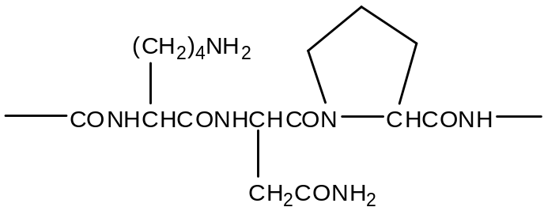

Draw the structure of the products formed when polypeptide Z is treated with excess aqueous NaOH under prolonged heating.

[2]
[Total: 8]
6 Beryllium is a Group II element which is found naturally in gemstones. Its high temperature stability makes it an ideal aerospace material.

(a) Beryllium does not follow the typical trends in Group II elements. Instead it shows a diagonal relationship with aluminium in Group III.

(i) Suggest the nature of beryllium oxide and write balanced equations to illustrate its nature.

(ii) Beryllium carbide, Be₂C, decomposes in the presence of water to give beryllium oxide and methane.

Be₂C + 2 H₂O → 2 BeO + CH₄

Hence or otherwise, suggest the decomposition equation for aluminium carbide, Al₄C₃.

[4]

(b) The thermal decomposition temperatures of Group II carbonates are shown in the following graph.

BeCO₃ MgCO₃ CaCO₃ SrCO₃ BaCO₃
Decomposition
temperature

(i) Explain the trend in the graph from MgCO₃ to BaCO₃.

(ii) Suggest why the decomposition temperature of BeCO₃ is much lower than what is expected in the trend.

[3]
(c) In gas phase, beryllium chloride exists as Be₂Cl₄, which is formed via dimerisation. Draw the displayed formula of Be₂Cl₄ and label all bond angles.

[2]
(d) (i) Beryllium fluoride, BeF₂, is a molecular compound. Explain why beryllium fluoride and sodium fluoride react in the molar ratio of 1:2 to form an addition product.

- Draw the dot-and-cross diagram for the compound formed between beryllium fluoride and sodium fluoride.

[2]
[Total: 11]

END OF PAPER

